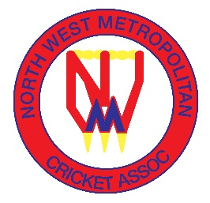
NORTH WEST METROPOLITAN CRICKET ASSOCIATION

UMPIRE FEES – SEASON 2025-26

1.13.1 UMPIRES’ FEES
The following daily umpire fees shall apply for Season 2025-2026:
Open-Age matches
Luscombe Shield
Single Umpire $210 2 Umpires $180 each
Kyte, Stringer & Attwater Shields
Single Umpire $180 2 Umpires $170 each
Muir, Seipolt & Clissold Shields
Single Umpire $170 2 umpires $150 each
Open Age One Day grades Saturday and Sunday, including Veterans Single Umpire $170 2 umpires $150 each
Open Age Twenty 20, Women’s Social T20 shields and divisions Single Umpire $100 2 umpires $90 each
Open-Age - Grand Final Matches
Luscombe Shield
Single Umpire $230 2 Umpires $190 each
Kyte, Stringer & Attwater Shield
Single Umpire $210 2 Umpires $180 each

Muir, Seipolt & Clissold Shield
Single Umpire $190 2 umpires $160 each
Open Age One Day grades Saturday and Sunday, including Veterans
Single Umpire $190 2 umpires $160 each

Open Age Twenty 20, Women’s Social T20 shields and divisions
Single Umpire $100 2 umpires $90 each

Under Age matches, including All Girls competitions
All Grades (including Twenty/20 matches)
Single Umpire $90 2 umpires $70 each

Under Age including All Girls competitions - Grand Final Matches
Single Umpire $100 2 umpires $80 each

