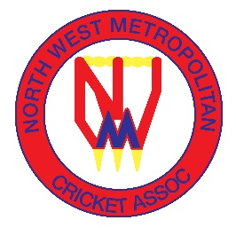
NORTH WEST METROPOLITAN CRICKET ASSOCIATION

UMPIRE FEES – SEASON 2026-27

1.13.1 UMPIRES’ FEES
The following daily umpire fees shall apply for Season 2026-2027:

Open Age / Senior Grades |  |  | Grand Final
Grade | Single Umpire | Two Umpires | Single Umpire | Two Umpires
Luscombe Shield | $230 | $200 each | $250 | $220 each
All other Two Day Grades | $200 | $170 each | $220 | $190 each
One Day Saturday / Sunday Grades | $180 | $150 each | $200 | $170 each
NWMCA Women’s Grades | $100 | $90 each | $120 | $110 each
Open Age T20 Comp | $100 | $90 each | $120 | $110 each
Junior panel umpire standing in Senior grade
Central Umpire | Full amount for grade | Full amount for grade | Full amount for grade | Full amount for grade
Square leg only |  | $140 |  | $160
Junior Grades |  |  | Grand Final
Junior Mixed and All Girls Grades | $100 | $80 each | $120 | $100 each

