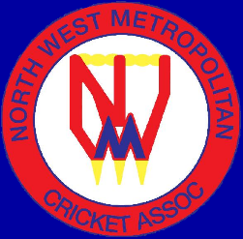
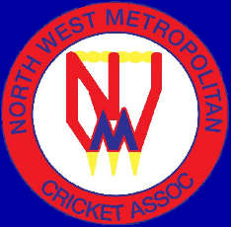
JUNIOR UMPIRES PANEL
EXPRESSION OF INTEREST
2024/2025

The NWMCA is seeking expressions of interest for young people to join our Junior Umpire panel for season 2024-2025. To apply, umpires MUST have turned 15 years old by 1 October 2024.
“Umpiring is one of the most important roles in Cricket and offers a fantastic avenue to be involved in the game you love. Whether you are seeking a career in umpiring or just wanting to be involved, umpiring develops life skills such as: Leadership, critical & clear thinking, decision making and effective communication” – Cricket Australia.
Within the NWMCA, we have a great track record of Umpires progressing through the higher grades of the NWMCA to Umpire for Cricket Victoria. Not to mention the ability to earn some money and being involved in Community sport.
To be considered for a position on the Junior Umpires Panel for season 2024/2025, please complete the details below and return to the NWMCA by FRIDAY 23rd AUGUST – save a copy of the form and send to:
admin1@nwmca.com.au (Bill Maddern)
admin2@nwmca.com.au (Vanessa Brooker)
First Name | Click or tap here to enter text.
Last Name | Click or tap here to enter text.
Your Age at 1/10/2024  Note: Minimum age to Umpire is 15 years old. | Click or tap here to enter text.
Email address | Click or tap here to enter text.
Mobile number | Click or tap here to enter text.
Home / landline number (if applicable) | Click or tap here to enter text.
Suburb where you live? | Click or tap here to enter text.
Your current or last Cricket Club? | Click or tap here to enter text.
Will you be playing cricket this season? | Click or tap here to enter text.
How far are you able to travel to get to games (please show approximate distance or suburbs you could get to for games Click or tap here to enter text.
Do you have any umpiring / refereeing experience?
(cricket or any other sport)

Click or tap here to enter text.
Have you umpired for the NWMCA in previous seasons?

Click or tap here to enter text.
Have you completed an umpiring course through Cricket Victoria?

Click or tap here to enter text.
Please indicate by ticking which days you would be interested in and available to umpire: -

Thursday evenings (mixed juniors) ☐

Friday evenings (mixed juniors) ☐

Saturday Mornings (mixed juniors) ☐

Sunday Midday (Women’s Social T20 matches) ☐

Monday evening (All Girls Juniors) ☐

Wednesday evening (All Girls Juniors) ☐

Once we have received your expression of interest, we will be in contact to discuss next steps. We very much look forward to hearing from you.

NWMCA Admin team
June 2024

